There are five questions; answer four.
1. Question about wind power

a) The power coefficient (C_{P}) of a wind turbine with the blade radius R= 35 m is described by the function of the tip speed ratio shown in Figure Q1.1.
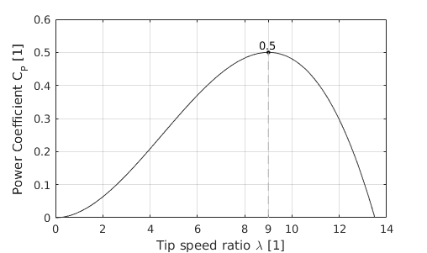
Figure Q1.1
Answer the following questions:
i) Explain what the power coefficient is. [3]
ii) Calculate the maximum power the aforementioned turbine can generate for a wind speed of v_{w}=9 m·s⁻¹ (assume an air density of ρ=1.225 kg·m⁻³). Determine the rotation speed and the torque of the turbine, T_{t} and ω_{T}, for that operating point. [2]
iii) Sketch the approximate turbine power as a function of the rotation speed for a wind speed of v_{w}=9 m·s⁻¹ and v_{w}=11m·s⁻¹. Mark the MPP in the graph. [2]
b) Concerning the estimation of the energy yield of a wind turbine:
i) Explain what the use of the Weibull distribution is when calculating the energy yield of a wind turbine. [2]
ii) Estimate the annual average wind speed and identify the frequency range (the bin in the histogram) that contains most kinetic energy given the histogram of wind speeds in Figure Q1.2. Justify your answer. [4]
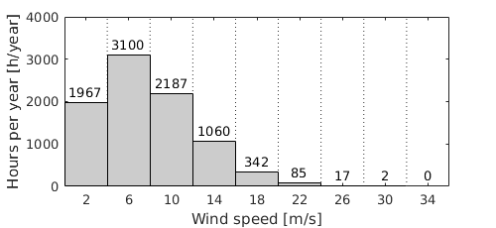
Figure Q1.2
Notes: The width of all bins is 4 m/s and they are centred in the wind speed value given in the bottom axis.
[continues in the back]
c) Concerning the following practical issues:
i) Explain the advantages and the disadvantages of the DFIG (Doubly-Fed Induction Generator) wind turbine when compared to the former SCIG (Squirrel Cage Induction Generator) wind turbine. [3]
ii) Wind turbines have a power limitation (or power reduction) operating region. Explain how they control the power reduction in this operating region. [4]
2. Question about solar photovoltaic (PV) generation
a) Consider a horizontal PV panel where γ is the elevation angle of the sunrays (see Figure Q2.1).
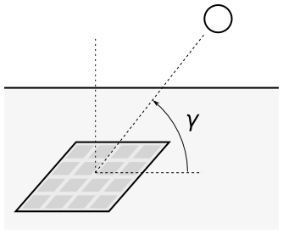
Figure Q2.1
i) Calculate the approximate Air Mass (AM) number for the elevation angle of γ = 62º [2]
ii) Calculate the total irradiation over the horizontal PV panel in kW if the surface of the PV panel is S=1.5 m², the direct irradiation in the direction of the sunrays is P_{direct}=900 W/m², the elevation angle is γ=62º and the diffuse irradiation is P_{diffuse}=180 W/m². [3]
b) A PV panel with 36 cells and a surface of 0.6 m² has the V-I curve shown in Figure Q2.2 for an irradiation of P= 1,000 W/m² and a temperature T=50ºC.
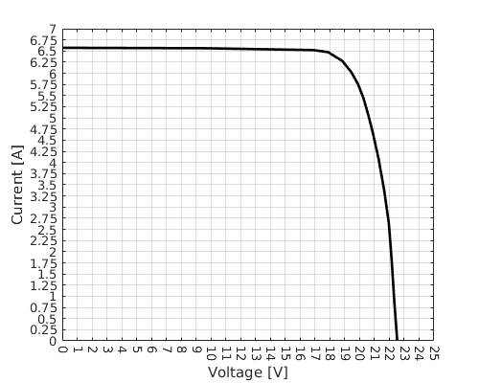
Figure Q2.2
i) Find the coordinates of the MPP of the PV panel (voltage, current and power) and calculate the efficiency of the panel at the MPP. [3]
ii) Describe a basic perturb-and-observe MPPT algorithm for a PV panel. Use an illustration of the characteristic curve of the PV panel to explain how the algorithm works. [3]
[continues in the back]
iii) Explain the problem related to connecting PV cells in series and the ways to prevent this problem. [3]
iv) Explain how the shape of the V-I curve of a PV cell changes with the irradiation and the temperature. [3]
c)
i) An illuminated traffic sign in London is powered autonomously using a South-facing PV panel which has an inclination angle α of 70º (see Figure Q2.3). A nearby South-facing rooftop PV panel has an inclination angle of 20º. Explain whether these angles are a reasonable choice and justify your answer. [3]
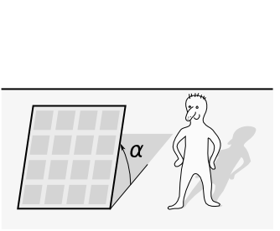
Figure Q2.3
3. Question about distributed generation and network security
a) Explain the historical rationale for the design of the distribution network by considering the relationship between the amount of peak demand that can be disconnected (lost) due to network outages and the allowed time to restore it. Sketch this relationship and indicate how the level of redundancy changes with the level of peak demand to be supplied. [4]
b) Explain the importance of considering the contribution that distributed generation can make to distribution network security. Explain how this may impact the competitiveness of distributed generation compared to large-scale central generation. [4]
c) Explain the concept of “capacity value” of distributed generation and the method of its calculation. [3]
d) Four distributed generation units are connected to the system via an overhead line as shown in Figure Q3.1. The shape of the load duration curve during the winter period (2,200 hours) is shown in Figure Q3.2. The knee point is at the duration of 200 hours and the power of 0.75 p.u. while the minimum power is 0.25 p.u. at 2,200 hours. Calculate the contribution to network capacity of these four identical distributed generation units, each of 2.5 MW and with the availability of 90%. [9]
~
~
~
~
Distributed generation
4 x 2.5 MW
90% availability
Load
Overhead line
Figure Q3.1 Figure Q3.2

4. Question about distributed generation and voltage control
a) Explain what factors could limit the amount of distributed generators that can be connected to urban and rural distribution networks. [4]
b) What control strategies and technologies could be applied to enhance the ability of the existing network to accommodate the increased capacity of distributed generation? [4]
c) The wind farm developer “West Sussex Wind” has applied for a connection of a wind farm to the local 33 kV distribution network shown in Figure Q4. In order to facilitate this connection, distribution network planning engineers need to investigate the effect of voltage rise on the network during minimum demand condition (given in the figure). The On-Load Tap Changing (OLTC) transformer 132/33 kV is set to maintain the voltage at the busbars B at 1.03 p.u. The calculation should be carried out in the per-unit system using base value power of 100 MVA.

P_{dmin} = 2 MW
Q_{dmin} = 0.2 MVAr
Wind farm
P_{w} = ?
Q_{w} = -P_{w}/10
Supply point
R = 3.9 Ohms
X = 9.5 Ohms
A
B
C
Demand
Network connection
OLTC transformer
Figure Q4

i) Estimate the amount of wind power generation that “West Sussex Wind” could connect to the network for the allowable voltage variation in the network of +/- 6%. [6]
ii) In order to further increase the amount of power generation that can be connected to the network, distribution planning engineers are considering modifying the control set point of the OLTC to 1.01 p.u. How much more generation would this allow to connect? [3]
iii) Calculate the amount of additional generation that “West Sussex Wind” could connect if reactive compensation of 2 MVAr (ind) is also connected to busbars C. [3]

5. Question about reserves (first part) and low carbon heat (second part)
a) In the future UK electricity system, it is expected that inflexible nuclear generation and variable and difficult to predict wind generation will make the key contribution to reducing the carbon emissions in electricity production.

i) Explain the advantages and disadvantages of providing reserves for managing uncertainty in wind power production by using part-loaded Combined Cycle Gas Turbines (spinning reserve) and Open Cycle Gas Turbines (standing reserve). [4]
ii) Discuss the advantages and disadvantages of applying demand side response in providing flexibility and peak demand reduction. [3]
iii) State the advantages and disadvantages of enhancing the flexibility of nuclear generation to provide reserve in a system with intermittent renewables. [3]
b) In order to achieve the UK’s target 80% reduction of CO₂ emissions by 2050, heat sector will need to be decarbonised.

i) Briefly outline the benefits and drawbacks of a district heating system. [4]
ii) A householder is considering installing a heat pump to replace her gas boiler. The heat pump is subsidised by the Government so that the cost is the same as that of a gas boiler. The householder’s annual heat demand averages 10 MWh and the electricity tariff is 12p/kWh whereas the gas tariff is 5.5p/kWh. Calculate the expected annual cost or saving of installing a heat pump stating any assumptions made. [3]
iii) Assuming the CO₂ emissions from gas combustion are 190g/kWh and those from grid electricity are 500 g/kWh, estimate the annual CO₂ savings of replacing the gas boiler by the heat pump. [3]

